CSE OOPS ASSIGNMENT 1
SUBMITTED BY: ADITYA GUPTA CSE 3RD SEM 25103008

1. Write a C++ program that declares variables of the following types: char, int, float,
double, bool, short, long and long long. Initialize them with suitable values and display
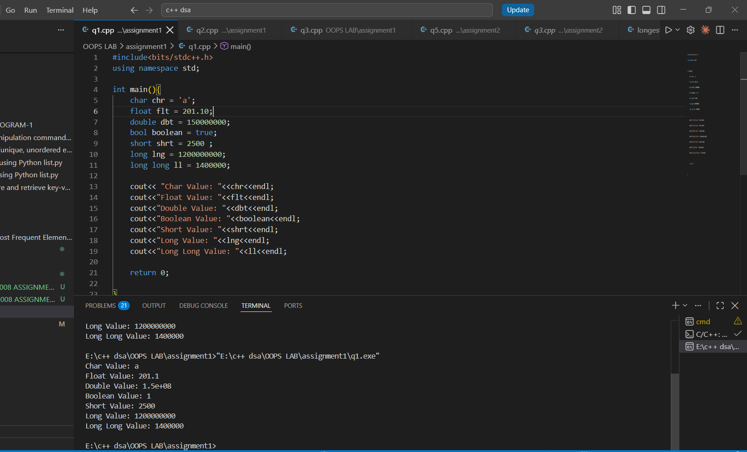
the value of each variable.

2. Write a program to display the Size of each data type using sizeof() for the variables
declared in Question 1.
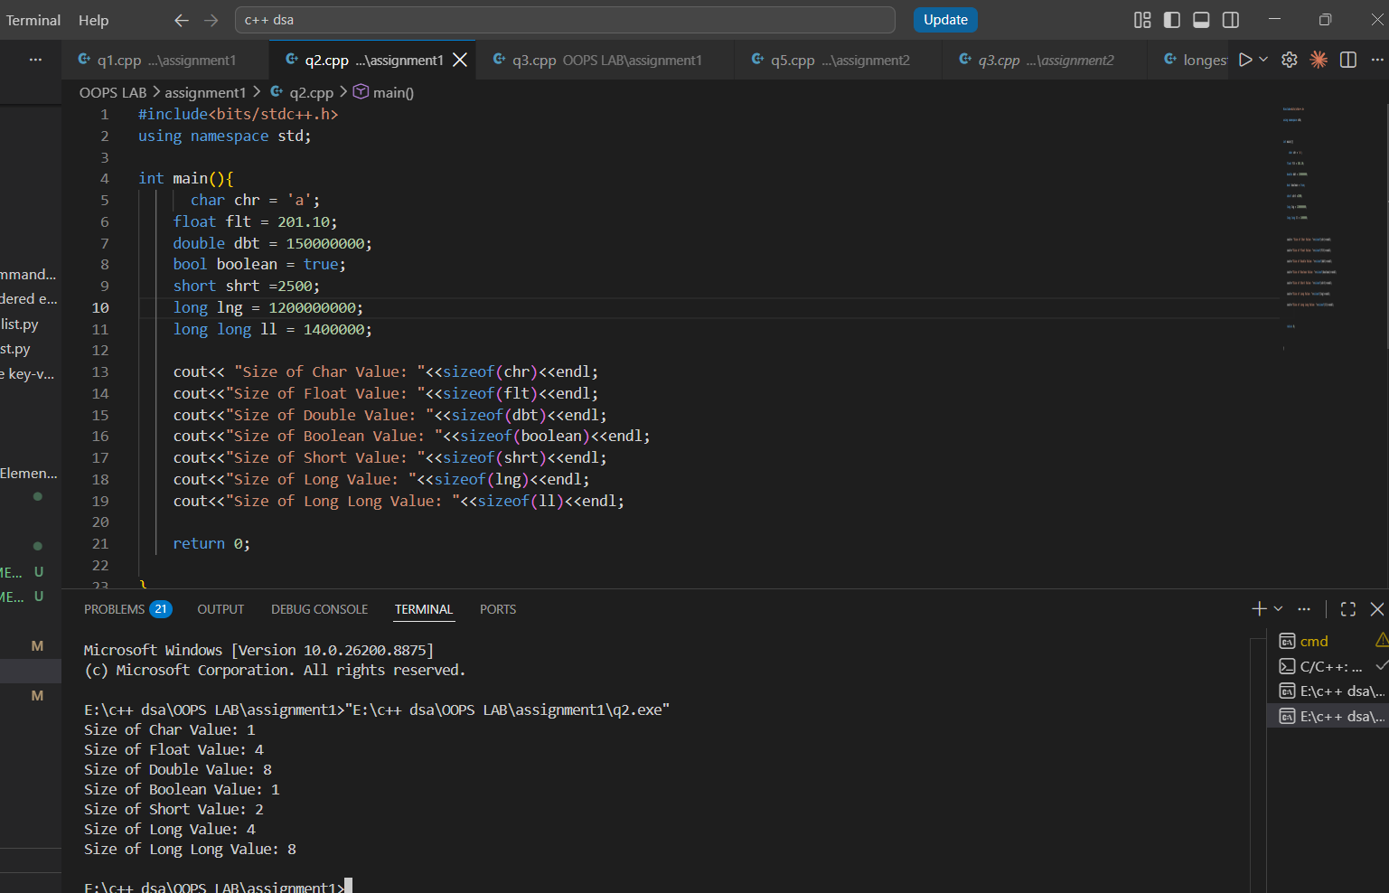

3. Write a program to display the minimum and maximum values of suitable integer data
types using the appropriate limits provided by C+ for the variables declared in Question
1.

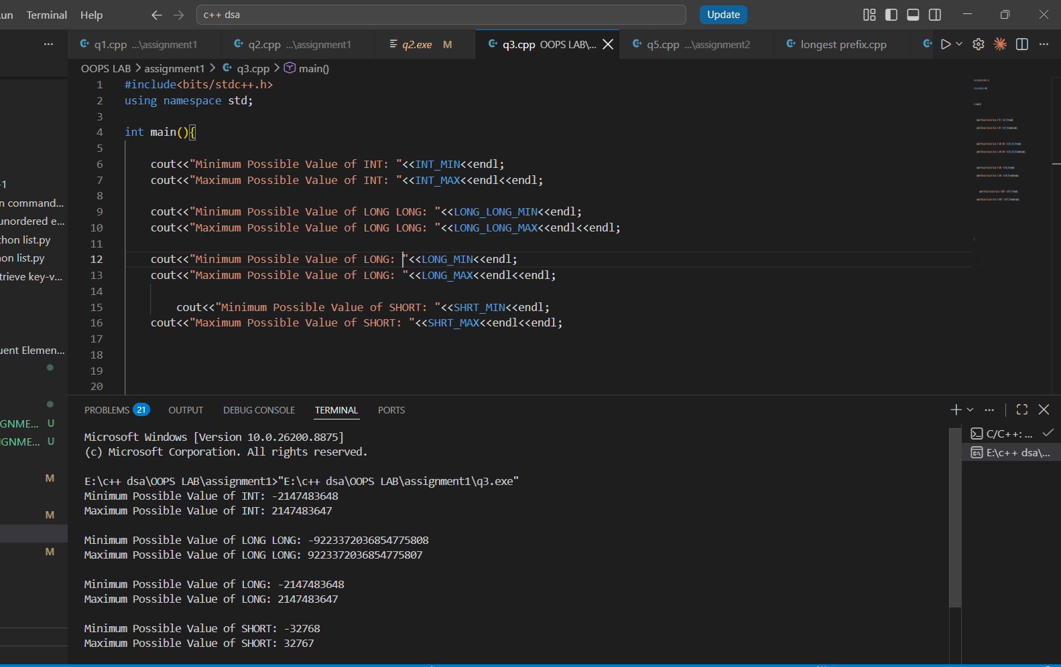

4. Write a program that accepts: Student name, Roll number, Branch, Marks in five
subjects. Calculate and display the Total marks, Percentage, Average marks, Highest
marks and Lowest marks. Use appropriate data types for each variable.
CODE:
#include<bits/stdc++.h>
using namespace std;
class Student{
public:
string student_name;
long long roll_number;
string branch;
vector<int> marks;

int total_marks(){
int sum=0;
for(auto i:marks){
sum+=i;
}
return sum;
}

float percentage(){
float sum=0;
for(auto i:marks){
sum+=i;
}
return ((sum/500)*100);
}

int average_marks(){
int sum=0;
for(auto i:marks){
sum+=i;
}
return (sum/5);
}

int highest_marks(){
int maxi=0;
for(auto i:marks){
maxi = max(i,maxi);
}
return maxi;
}

int lowest_marks(){
int mini=100;
for(auto i:marks){
mini=min(mini,i);
}
return mini;
}
};

int main(){

Student s1;

cout<<"Enter Student Name: ";
cin>>s1.student_name;

cout<<"Enter Roll Number: ";
cin>>s1.roll_number;

cout<<"Enter Branch: ";
cin>>s1.branch;

for(int i=1;i<=5;i++){
int temp;
cout<<"Enter Marks in Subject "<<i<<": ";
cin>>temp;
s1.marks.push_back(temp);
}

cout<<endl<<"------REPORT CARD--------";
cout<<endl<<"Student Name: "<<s1.student_name;
cout<<endl<<"Roll Number: "<<s1.roll_number<<endl;

cout<<endl<<"Total Marks: "<<s1.total_marks();
cout<<endl<<"Percentage: "<<s1.percentage()<<"%";
cout<<endl<<"Average Marks: "<<s1.average_marks();
cout<<endl<<"Highest Marks: "<<s1.highest_marks();
cout<<endl<<"Lowest Marks: "<<s1.lowest_marks();

return 0;

}
RESULT:
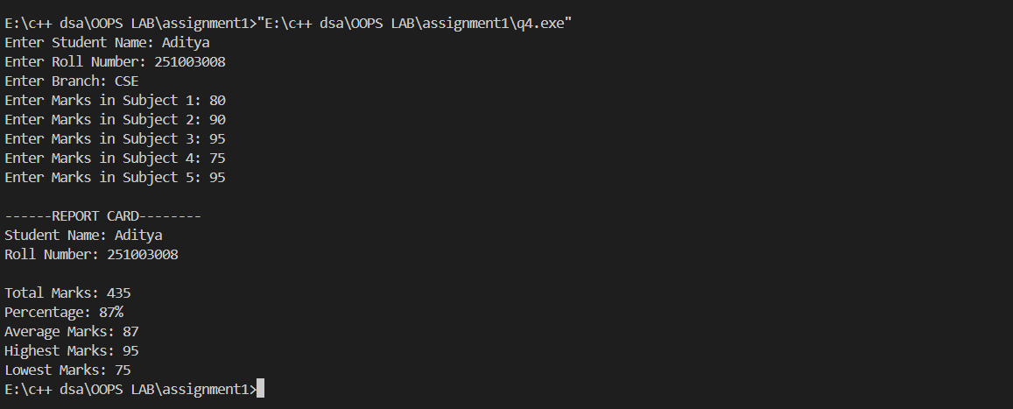

5. Write a program that accepts two integers and perform division of these integers and
display result in floating point number. Use appropriate type conversion for this and
understand the concept of type casting.
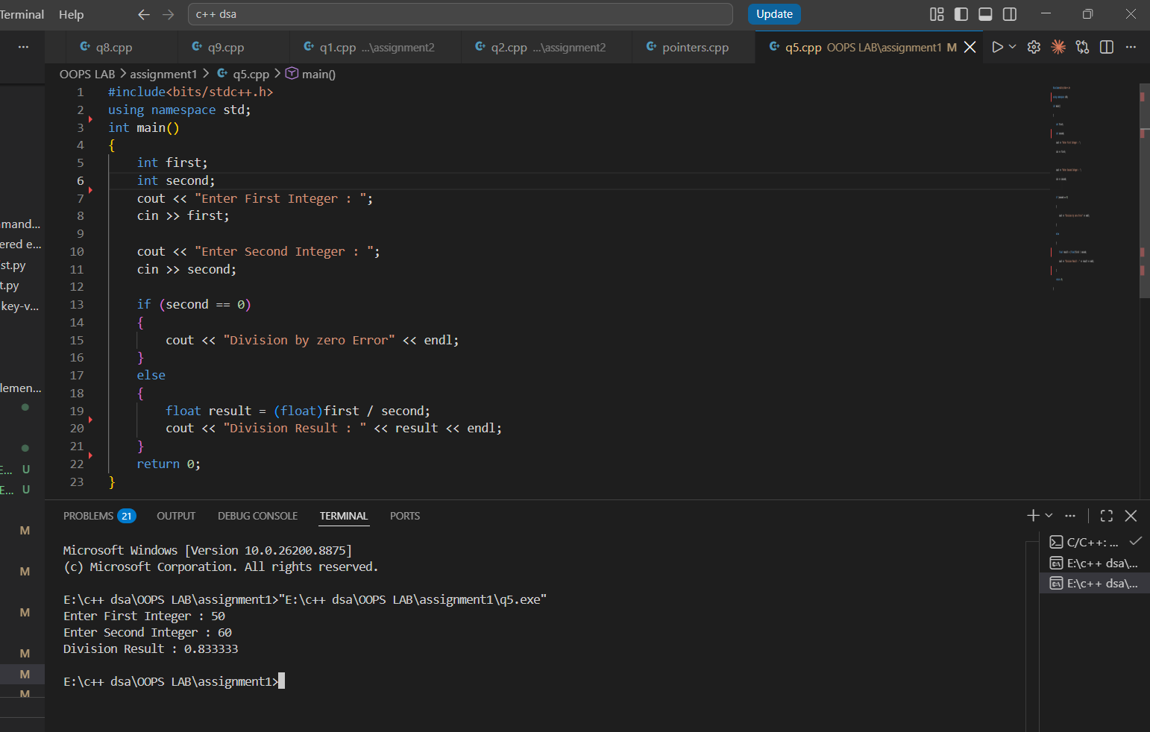

6. Write a program to evaluate:
result = (a + b * c) > d && (e != f || g <= h);
Accept all required values from the user. Also, tell about the precedence and
associativity of each operator used in this expression.
CODE:
#include<bits/stdc++.h>
using namespace std;

int main()
{
int a, b, c, d;
int e, f, g, h;

cout << "Enter value of a : ";
cin >> a;

cout << "Enter value of b : ";
cin >> b;

cout << "Enter value of c : ";
cin >> c;

cout << "Enter value of d : ";
cin >> d;

cout << "Enter value of e : ";
cin >> e;

cout << "Enter value of f : ";
cin >> f;

cout << "Enter value of g : ";
cin >> g;

cout << "Enter value of h : ";
cin >> h;

bool result = (a + b * c) > d && (e != f || g <= h);

cout << endl;
cout << "Result of Expression : " << result << endl;

cout << endl;
cout << "Operator Precedence Used :" << endl;
cout << "1. *" << endl;
cout << "2. +" << endl;
cout << "3. >" << endl;
cout << "4. !=" << endl;
cout << "5. <=" << endl;
cout << "6. ||" << endl;
cout << "7. &&" << endl;

return 0;
}
RESULT:
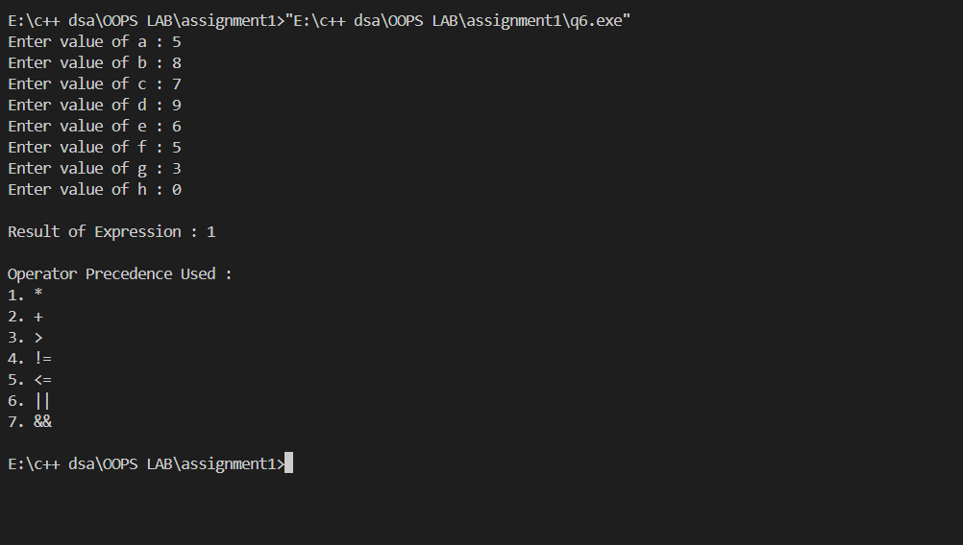

7. Write a program that accepts three numbers and determines the largest number using
the conditional (?:) operator only.

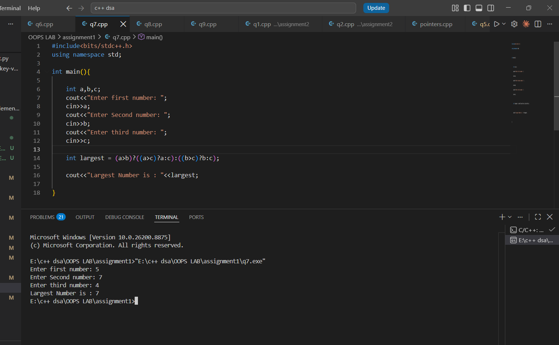

8. Write a program to demonstrate the use of the comma operator. The program should
initialize a variable using comma expressions. For example,
int x;
x = (10, 20, 30);
and understand the logic behind the value stored in x

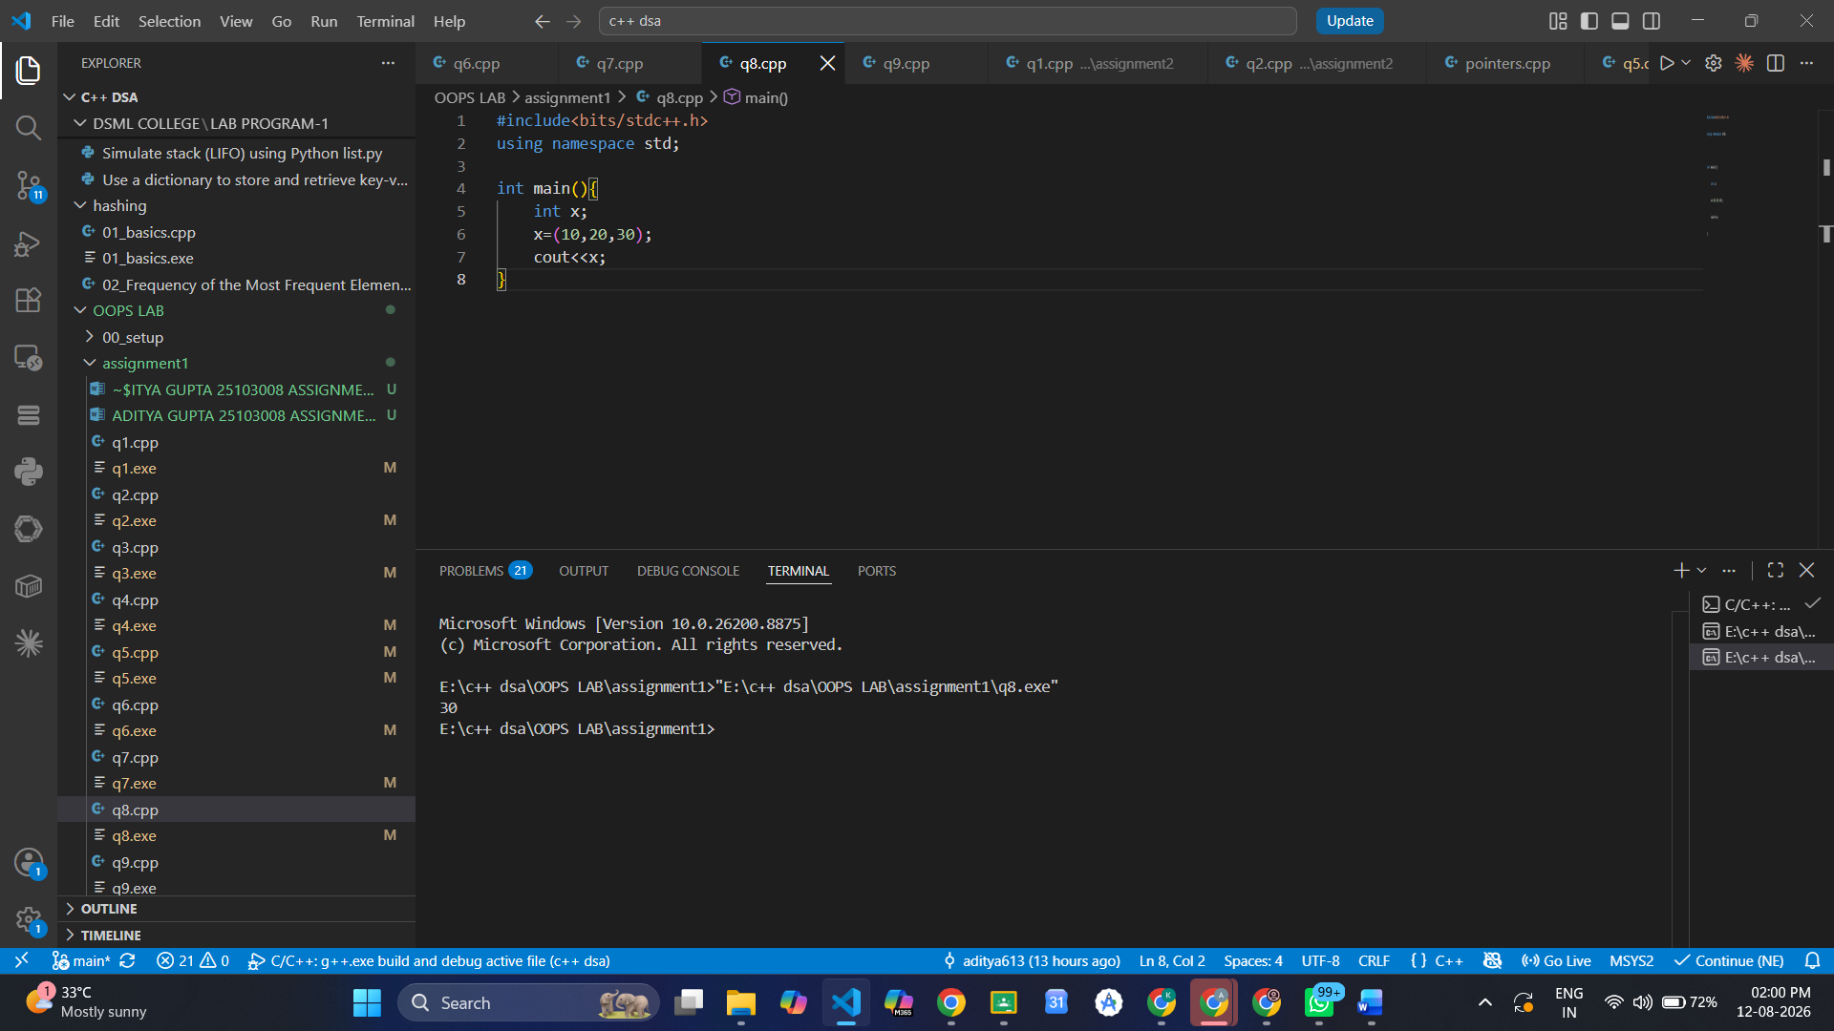

THE COMMA OPERATOR EVALUATES EXPRESSIONS FROM LEFT TO RIGHT AND ASSIGNS THE RIGHTMOST EXPRESSION/VALUE.

9. Write a program below given program and check how Comma Operator works.
int a, b, c;
a = (b = 5, c = 10, b + c);
int x = 10;
x = (x += 5, x *= 2, x -= 4);
cout<<a<<x;

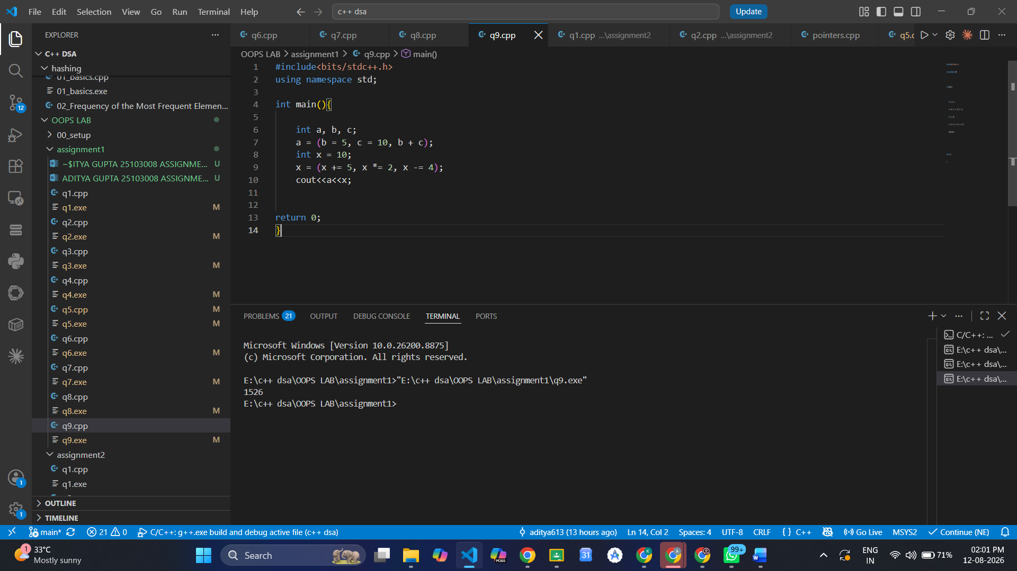

In this program, the expressions are executed from left to right. First, b is assigned 5 and c is assigned 10, then b + c gives 15, so a becomes 15. Similarly, x starts with 10, then 5 is added to make it 15, it is multiplied by 2 to become 30, and finally 4 is subtracted to get 26. Therefore, the output is 1526.

10. Write a program that accepts two integers and displays: a & b; a | b; a ^ b; ~a; a << 1;
a >> 1. Display the values in decimal.
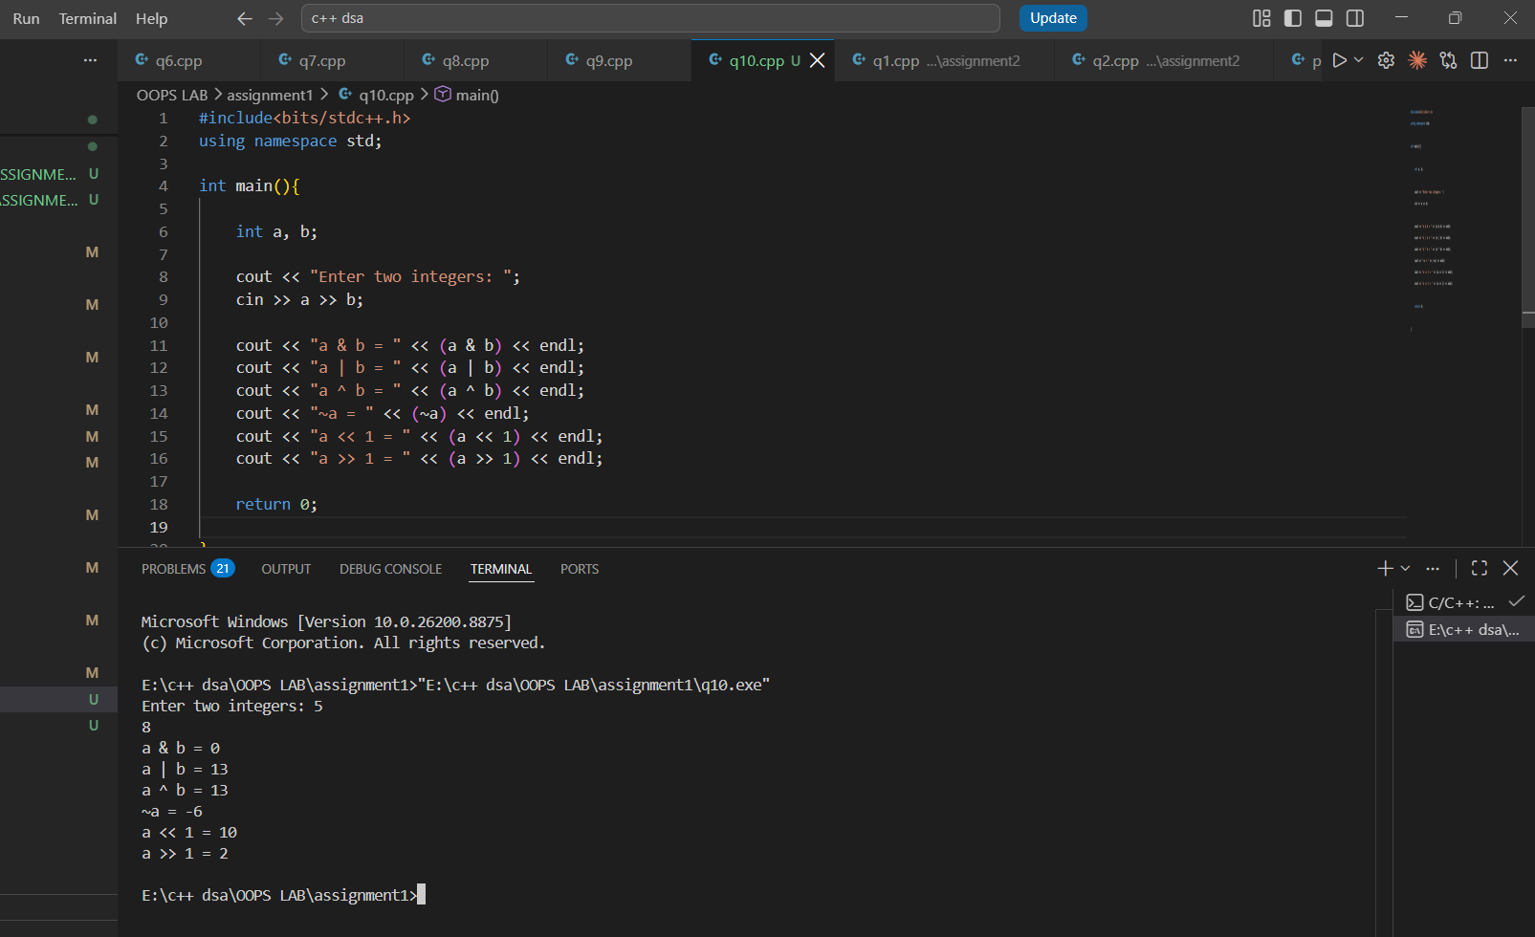
This program accepts two integers and performs different bitwise operations on them. & performs AND, | performs OR, ^ performs XOR, ~ gives the complement of a, << 1 shifts the bits of a one position to the left, and >> 1 shifts them one position to the right. All results are displayed in decimal form.

11. Write a program to determine whether an integer is odd or even using only bitwise
operator &.

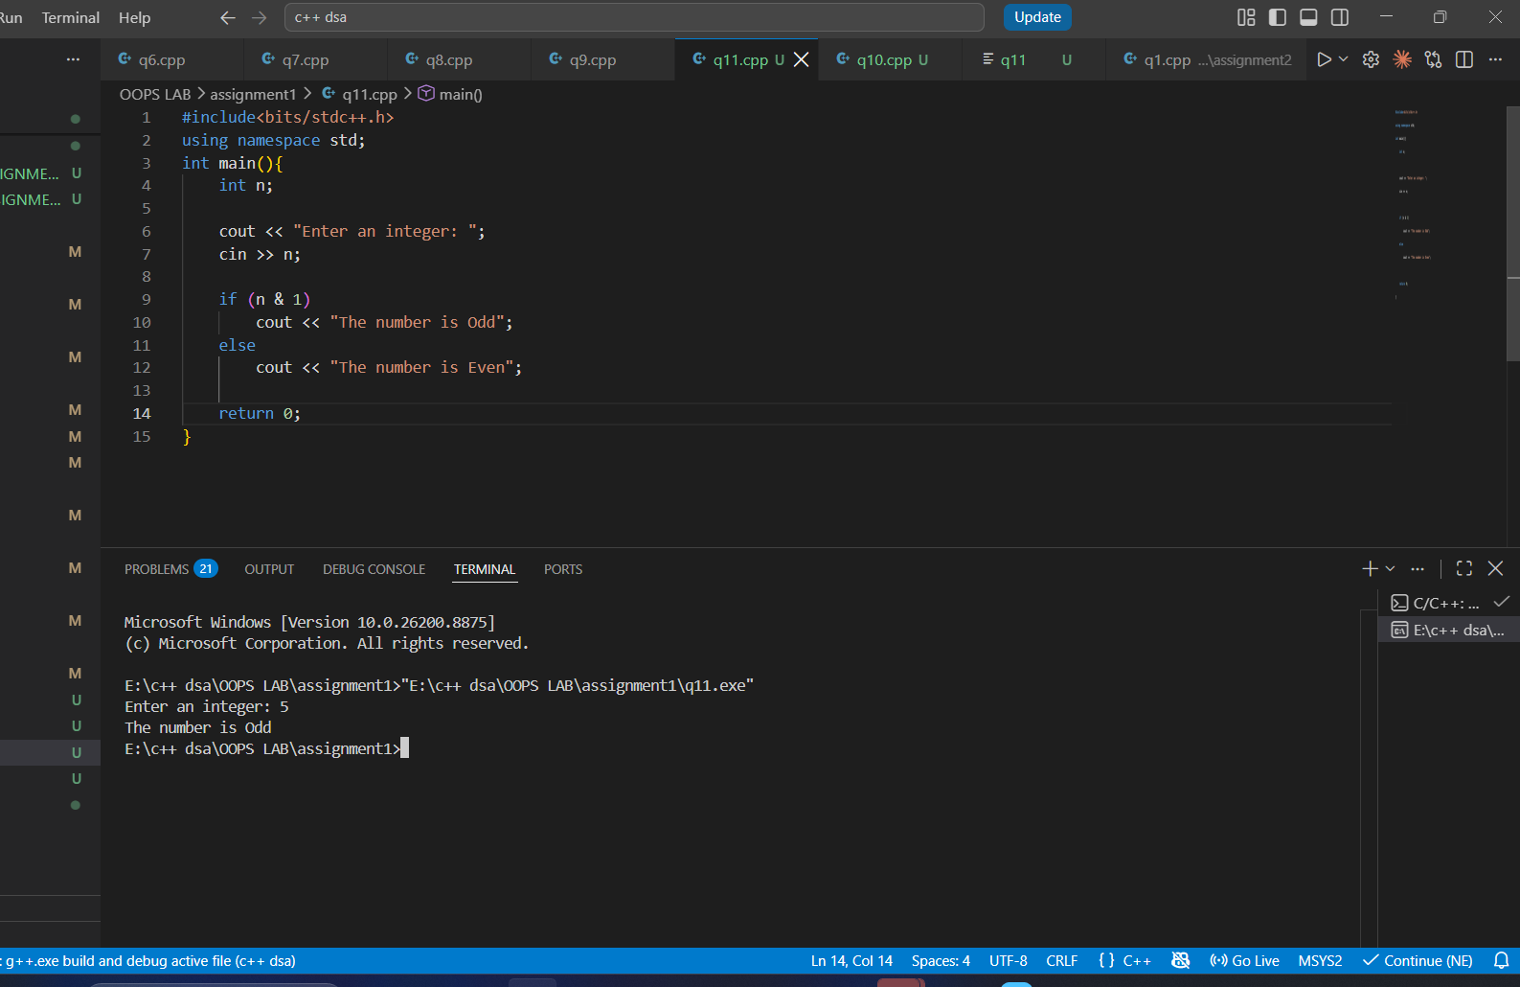
The program uses the bitwise & operator with 1 to check the last bit of the number. If n & 1 gives 1, the number is odd; if it gives 0, the number is even.

12. Write the following below given program and determine the exact output. Show
the values after every function call and justify your answer.
#include <iostream>
using namespace std;
int x = 10;
void fun(int x)
{
static int s = 2;
int y = x + s;
s += x;
::x += y;
cout << x << " " << y << " " << s << " " << ::x << endl;
}
int main()
{
int x = 3;
for (int i = 1; i <= 4; i++)
{
x += i;
fun(x);
}
cout << x << " " << ::x << endl;
return 0;
}
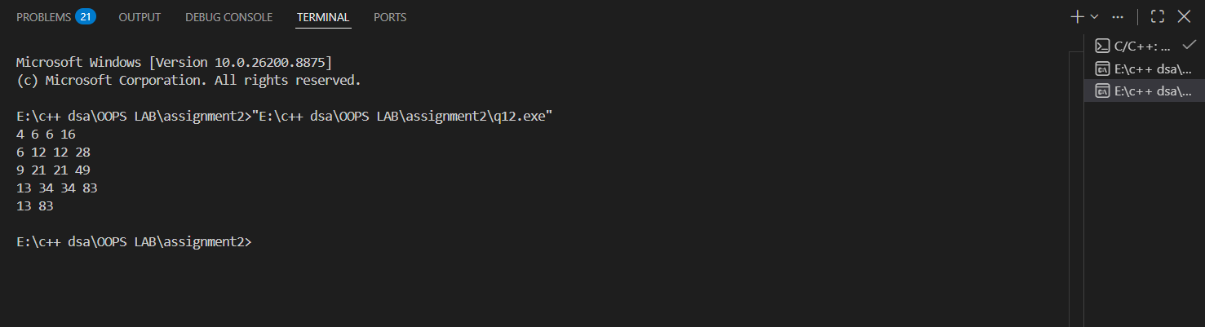
The local x in main() starts at 3, while the global x is 10. The variable s inside fun() is static, so it keeps its value between function calls.

